**Mission Science Report 5/4/2014: Clear-Air Flight**

Today we flew the ER-2 on a clear-air (CA) mission (Fig 1a), the first of the campaign. It was a nice dry day with a subsidence inversion around 600 mb and well-mixed CBL. Takeoff was at 1500 UTC from WRB and the working instruments flown included EXRAD, HIWRAP, CRS, AMPR. A sounding was taken at 1600 UTC (Fig. 1b; from UNC Asheville site which is on the center-west side of the middle of the pattern- see fig 1a below.) All looked decent in the AMPR data and the flight seemed to go off without a hitch.

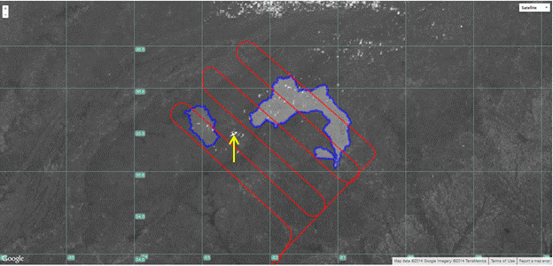**Figure 1a), below:** GOES-13 1 km Visible image at 1800 (after pattern finish). Yellow arrow points at the OPS center location at AVL airport. Only a few small cumulus (capped) were found along the way.

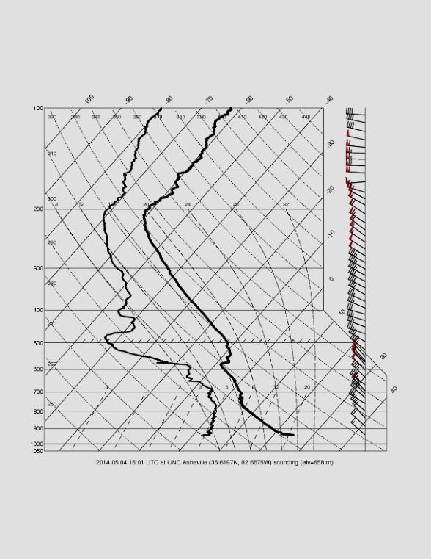

**Figure 1b)** Sounding taken at 1600 UTC an UNC Asheville

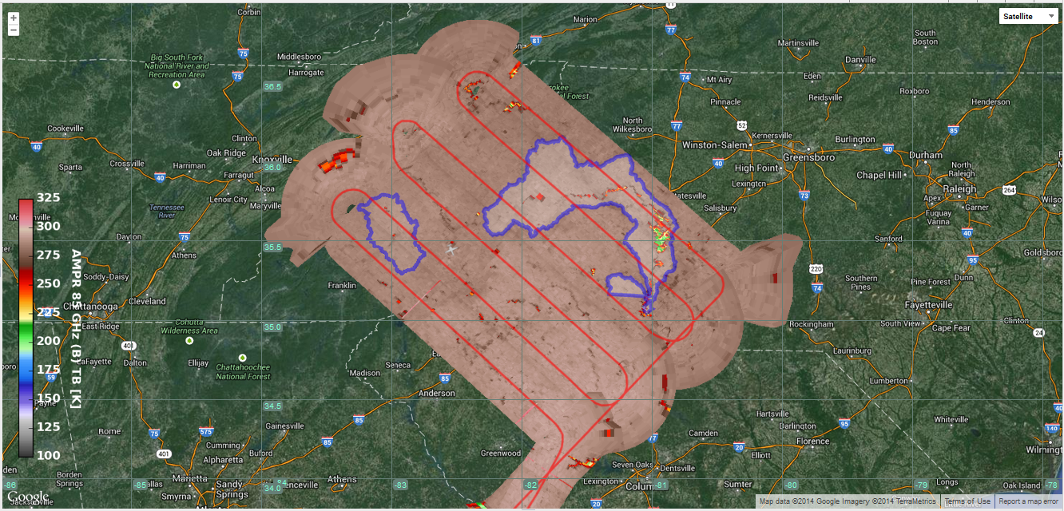**Figure 2, below**: AMPR 85 GHz (B) channel brightness temperatures with flight track of the clear-air pattern, Pigeon and Upper Catawba Watersheds are overlaid. A sounding was launched from Asheville, a bit north of where the little grey airplane is located east of the Pigeon (that is the Ops Center location).

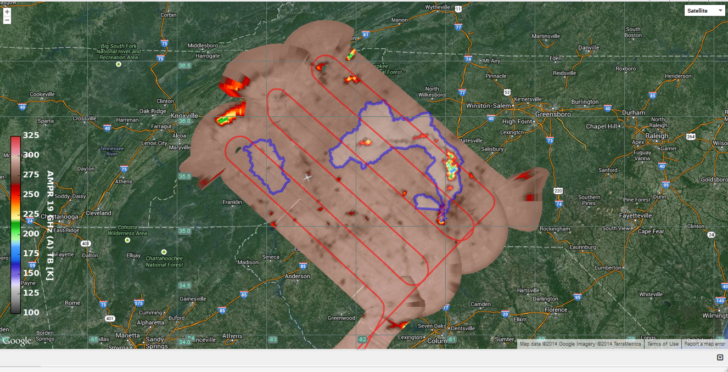**Figure 3,** below: As in figure 2, but, AMPR 19GHz A channel.

The forecasts for this flight were dead on at least 3 days ago. So, kudos to the forecasters and I guess, the models. We had only a few scattered cumulus clouds of no consequence. The blue sky also allowed us to see the ER-2 as he flew by (even at 65 kft).

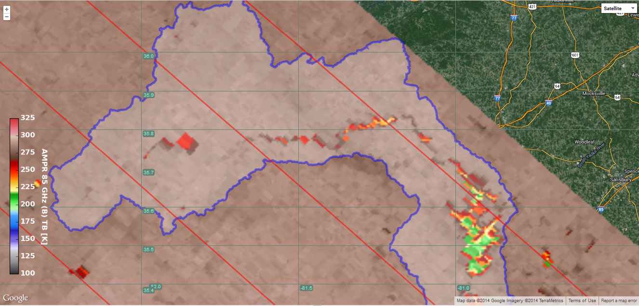**Figure 4, below**: AMPR 85 GHz (B) as in Fig. 2, but close up of the upper Catawba watershed.

The ER-2 entered the CA pattern on its northeast side around 1540 UTC and completed the pattern around 1742 UTC. He landed back at WRB at approximately 1825 UTC according to plan- roughly a 3.5 hour flight. We will want to do this again at our earliest opportunity with CoSMIR onboard.

We will have a GPM overpass tomorrow at 1430 and the GMI should cover this domain; so, if not too cloudy, things may be close enough in time that the comparison should be interesting to today’s flight. There will be a soil moisture flight tomorrow by the SLAP instrument at around 1400 UTC (with a sounding) so, with not much change expected in weather, the data may be a useful proxy for today’s CA mission.

During the clear air flight, Asheville Ops noticed pileus clouds forming over small cumulus, indicative of a capping layer. This is consistent with the sounding above. Here are some photographs taken by Mike Poellot (UND/Citation).

**Figure 5 (a,b)**: Photographs of clouds observed from ground during ER-2 Clear Air mission. Pileus clouds were observed over patchy cumulus. The pileus clouds evolved rapidly over time, typically 5-15 minutes. 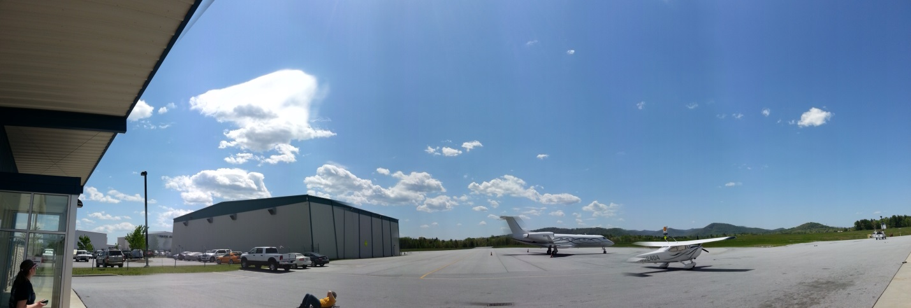

Walt Petersen/Ben Johnson